POVERTY POINT - COMPUTER

http://viewpure.com/obIvQCGcxro?start=0&end=0

(YOU NEED TO PLACE THE MOUSE ON THE WEB ADDRESS AND HOLDING DOWN THE CTRL KEY AAND CLICK TH LEFT BUTTON ON THE MOUSE)

  - Why do most societies need agriculture to settle into urban societies?

  - Why did Poverty Point Native Americans not need agriculture to survive as an urban center?

  - How do archaeologists know Poverty Point was a major trade center?

  - What aspect of Poverty Point’s location make it ideal for a trade center?

Geographic/Historical Characteristics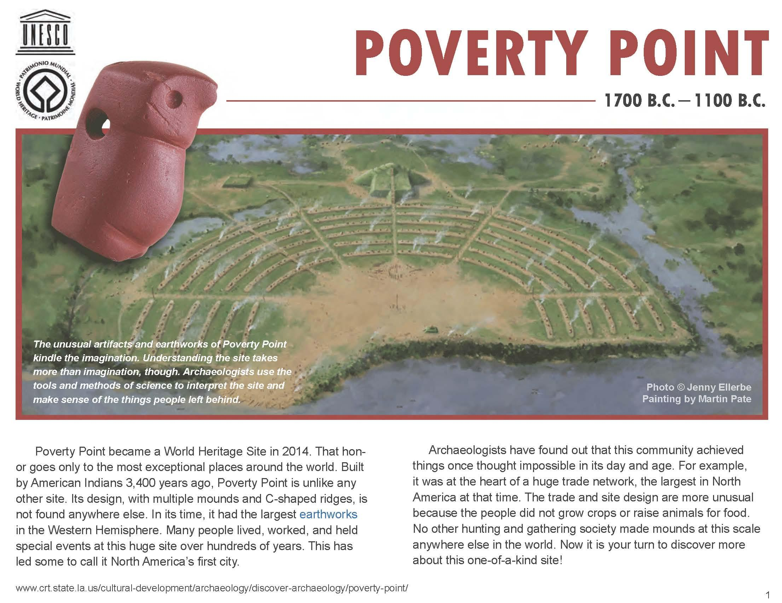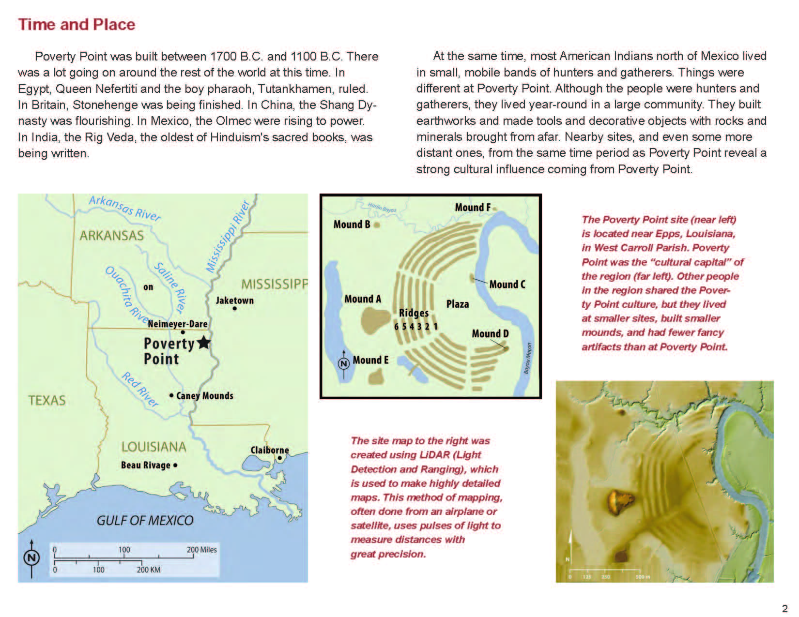

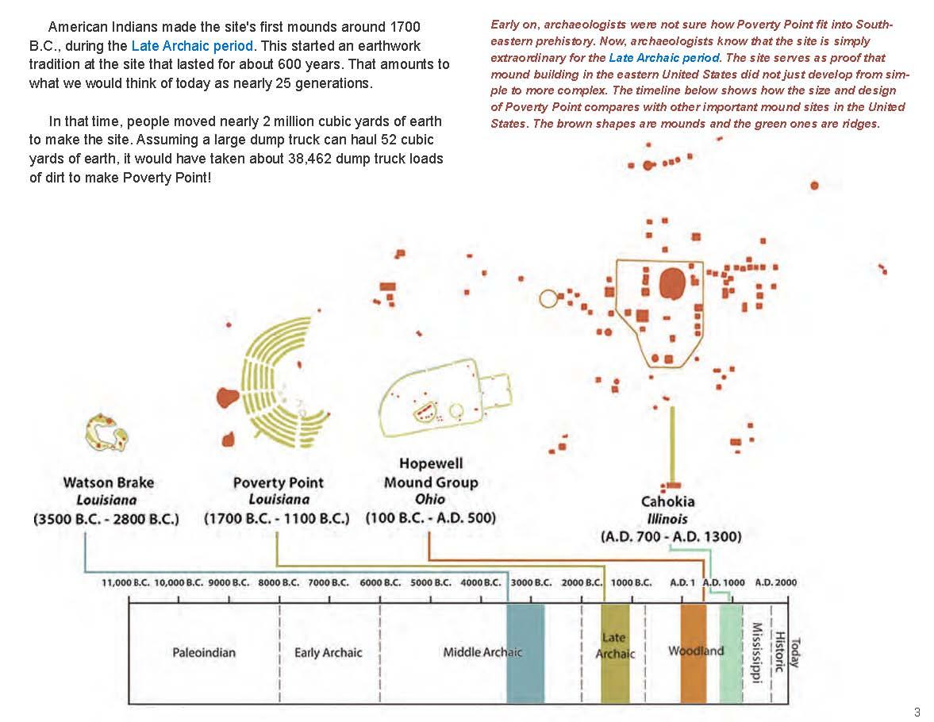
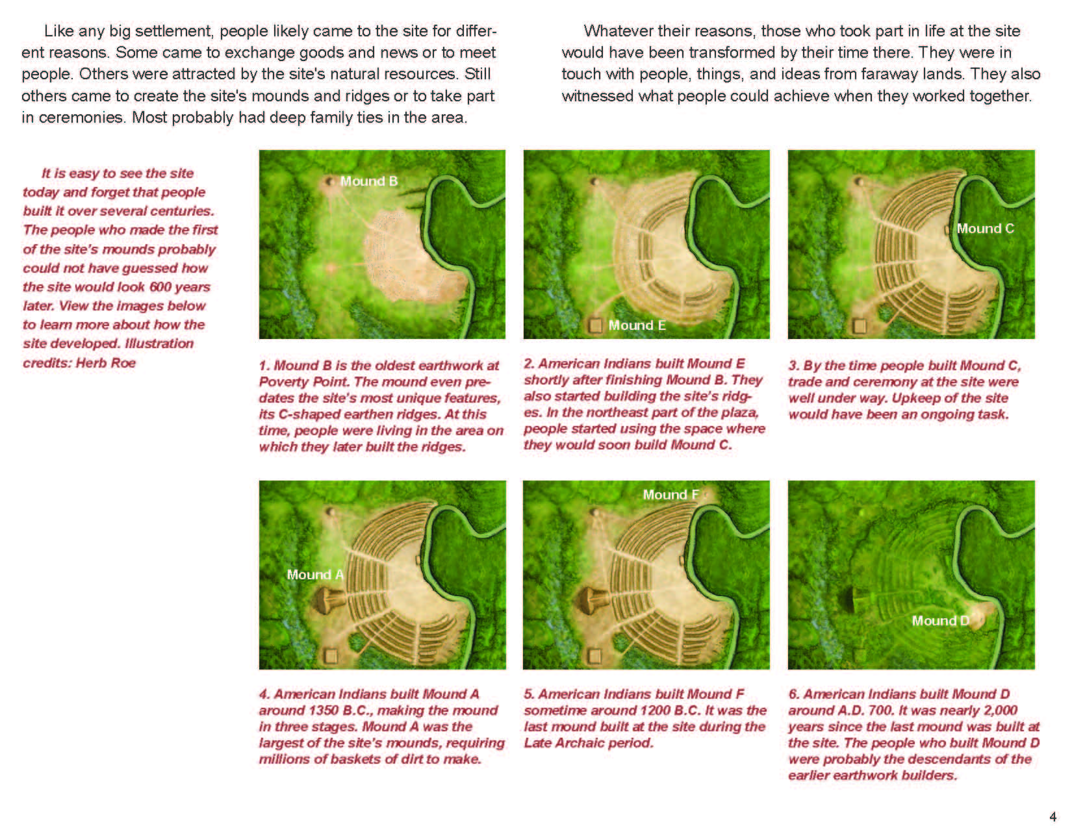
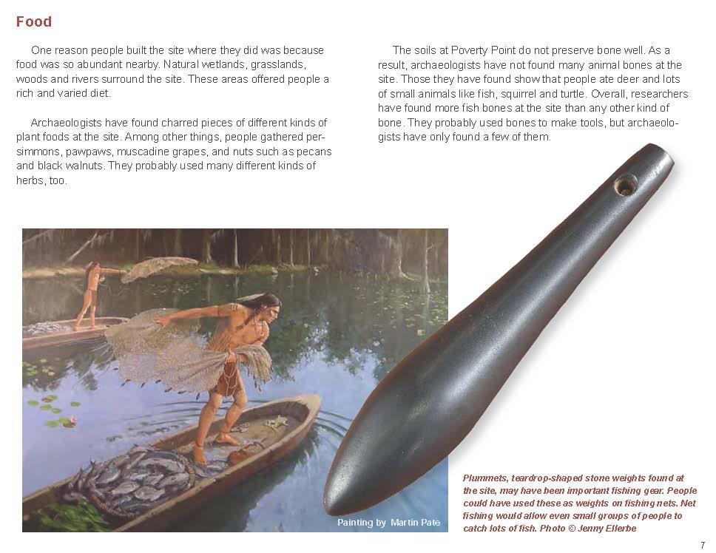
This work from the Louisiana Department of Culture, Recreation & Tourism is used with permission. The original work is available at http://www.crt.state.la.us/dataprojects/archaeology/povertypoint/assets/poverty-point-pdf-1.03.pdf.

Cultural Characteristics of Poverty Point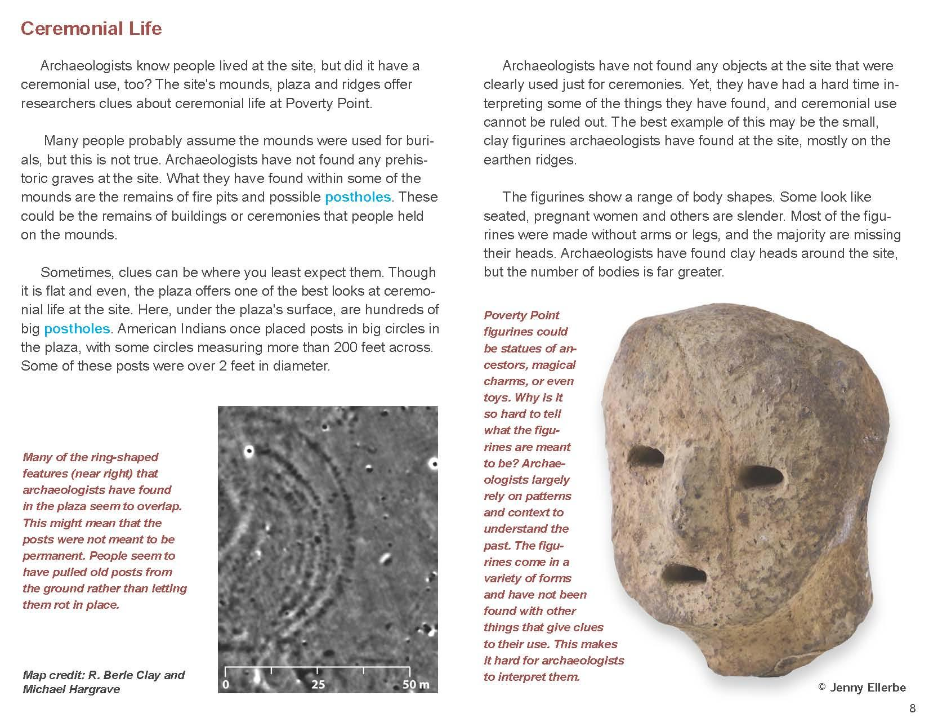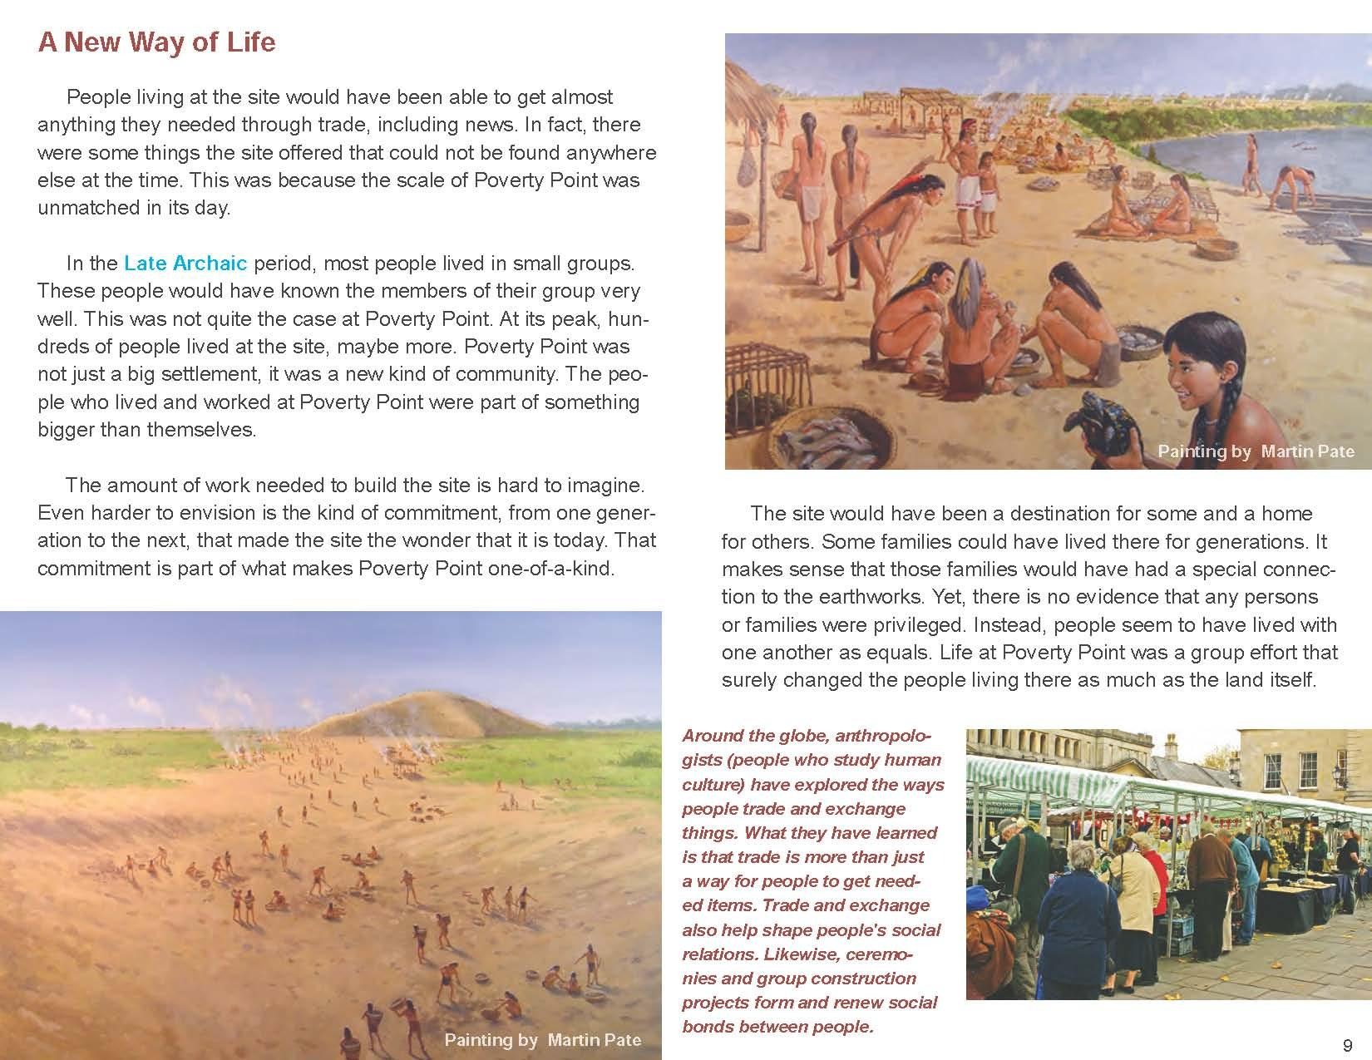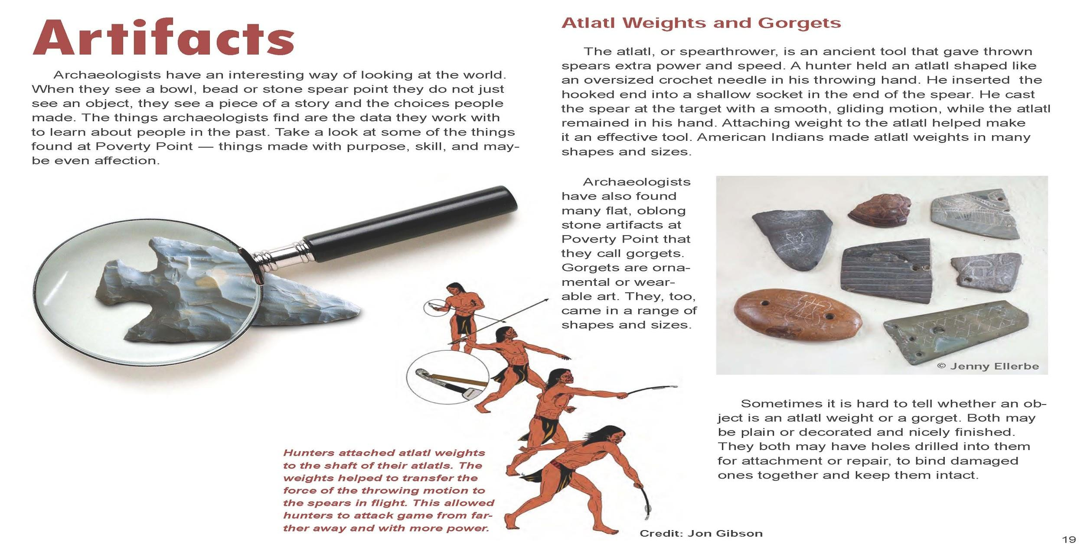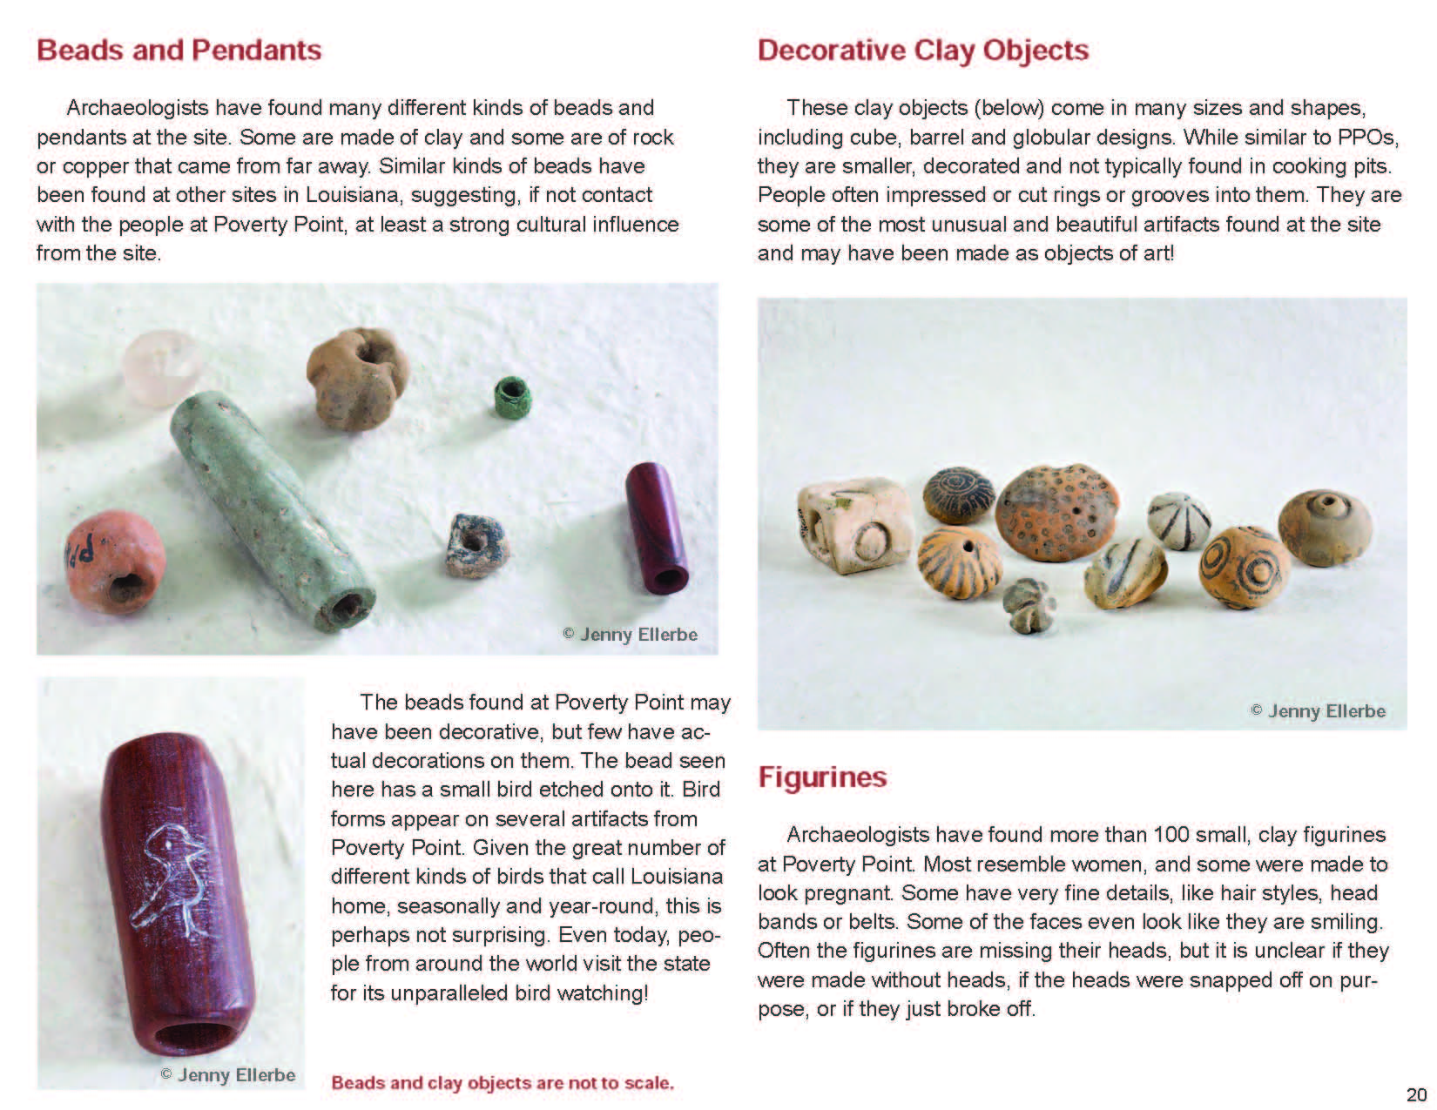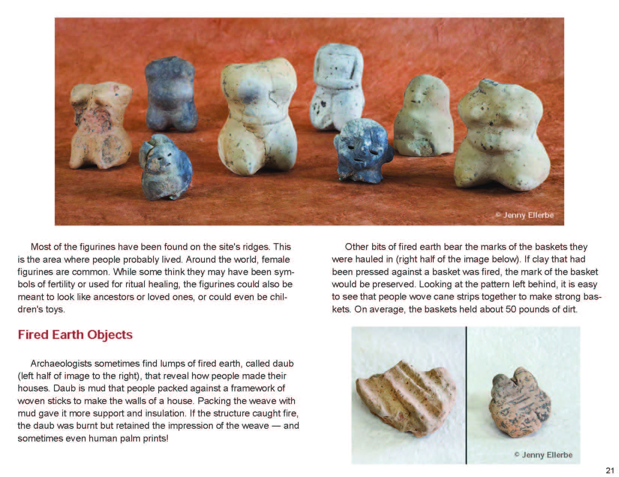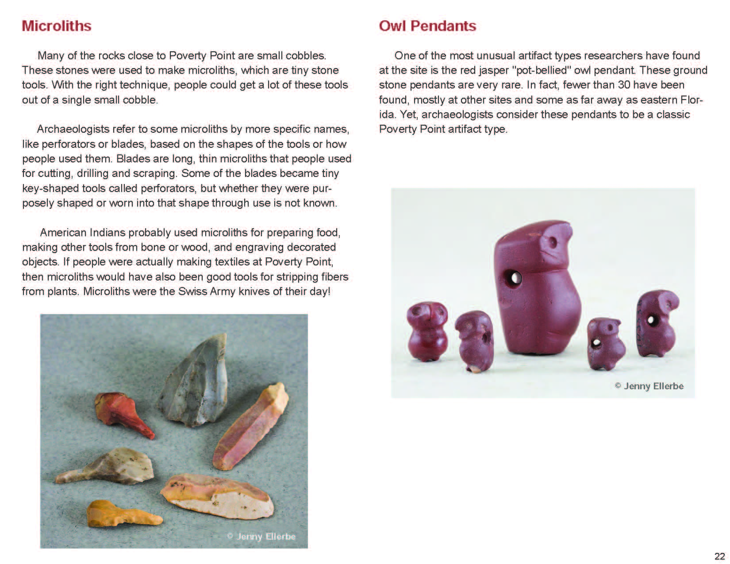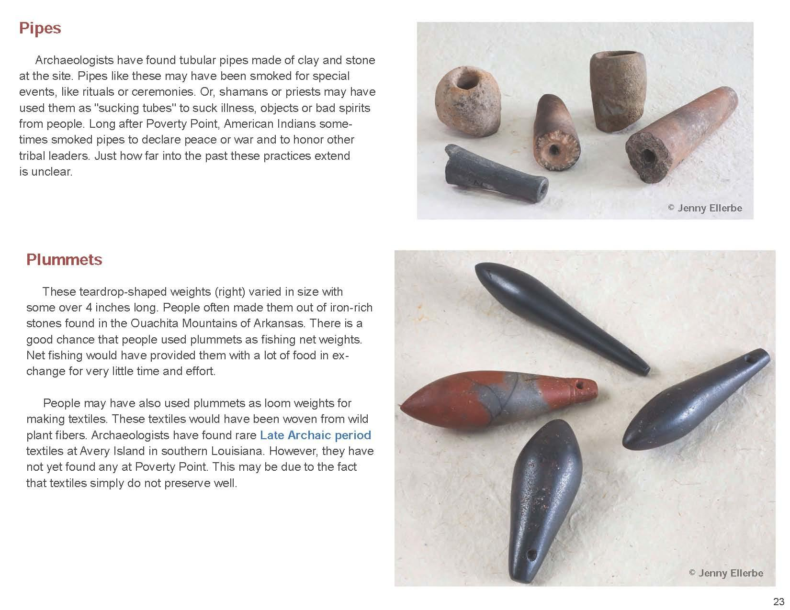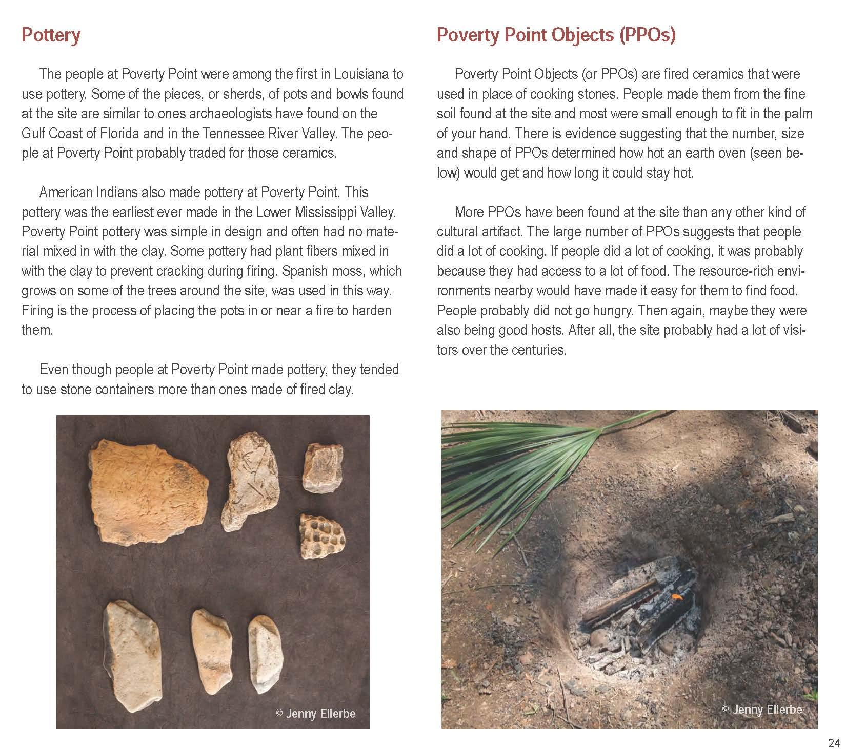
This work from the Louisiana Department of Culture, Recreation & Tourism is used with permission. The original work is available at http://www.crt.state.la.us/dataprojects/archaeology/povertypoint/assets/poverty-point-pdf-1.03.pdf.

Economic Characteristics of Poverty Point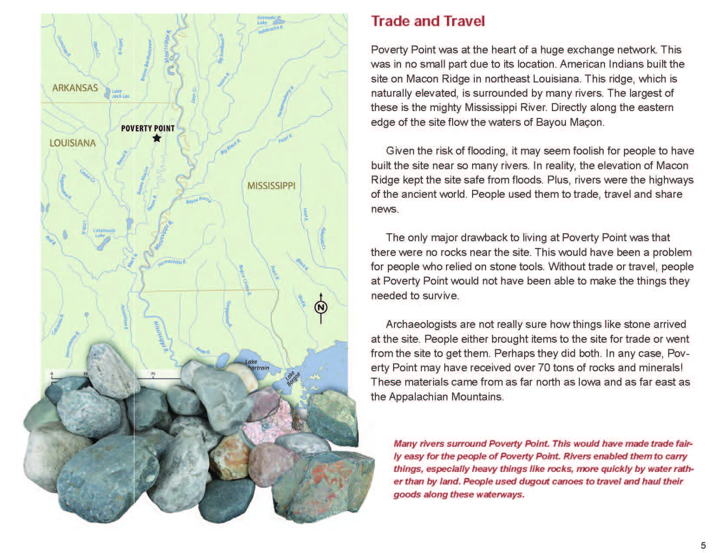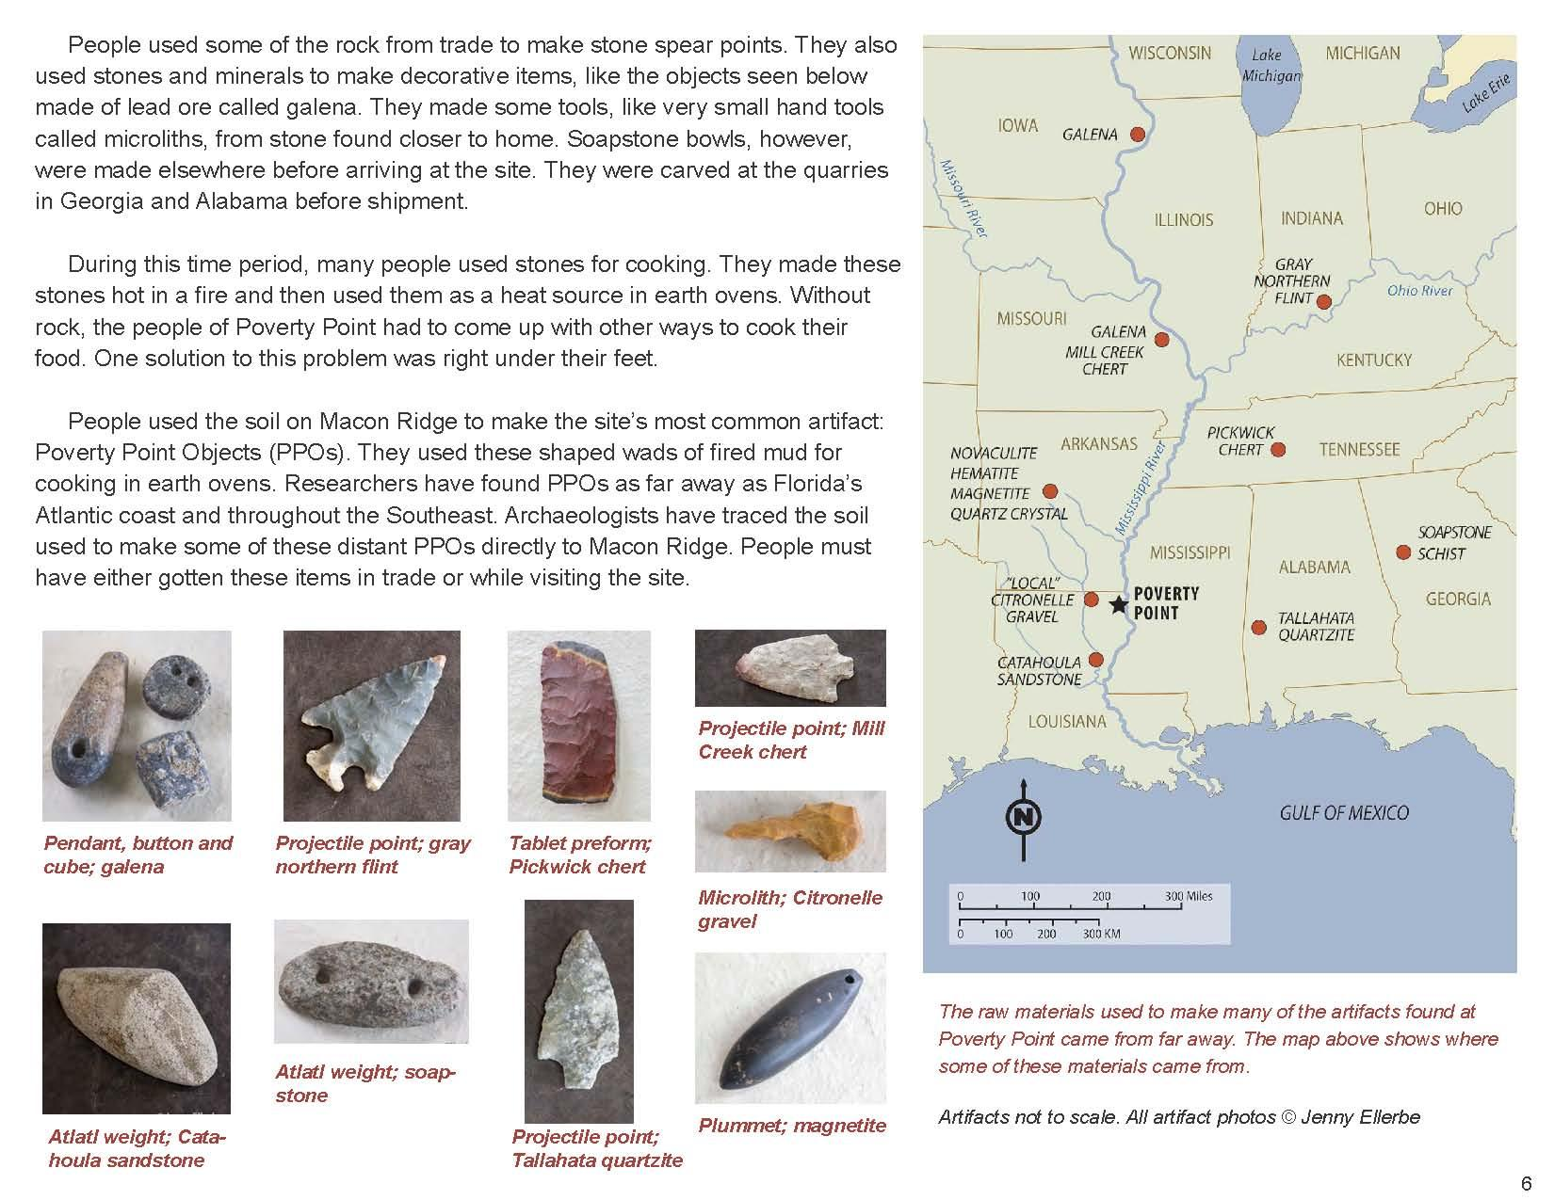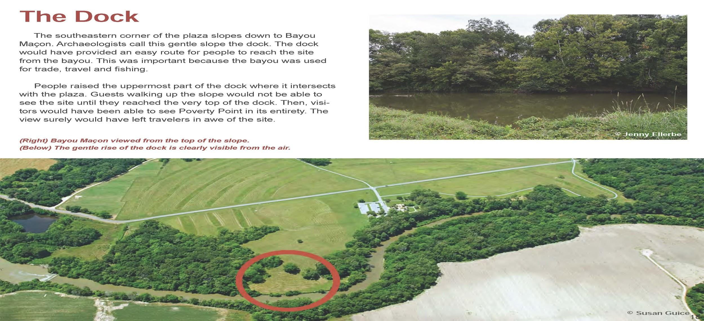
This work from the Louisiana Department of Culture, Recreation & Tourism is used with permission. The original work is available at http://www.crt.state.la.us/dataprojects/archaeology/povertypoint/assets/poverty-point-pdf-1.03.pdf.

